1.1 Logical Scheme
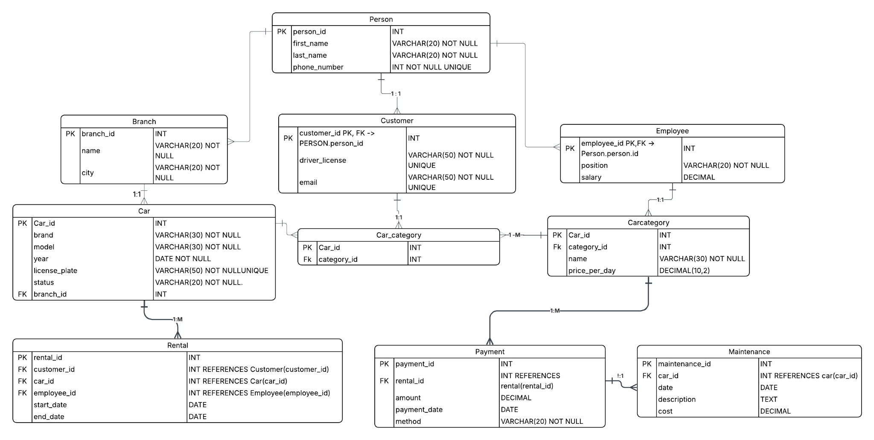

1.2 Objects

Table: Person
Stores personal information for all individuals in the system — both customers and employees. Each person has a unique identifier (person_id) and is identified by their first and last name and a unique phone number used for contact purposes.
Table Description
Field Name | Data Type / Constraints | Description
person_id | INT, PK | Unique identifier for each person. Auto-incremented primary key.
first_name | VARCHAR(20), NOT NULL | Given name of the person. Cannot be empty.
last_name | VARCHAR(20), NOT NULL | Family name of the person. Cannot be empty.
phone_number | INT, NOT NULL, UNIQUE | Contact phone number. Must be unique across all persons.

Example Data
person_id | first_name | last_name | phone_number
1 | Alexei | Morozov | 87011234567
2 | Dinara | Bekova | 87029876543
3 | Carlos | Fernandez | 87035551234
4 | Fatima | Al-Rashid | 87040001122

Table: Customer
Extends the Person entity with rental-specific customer information. A customer must have a valid driver's license to rent a vehicle. Each customer record is linked to a Person record via customer_id (FK). Email addresses are stored for billing notifications and account management.
Table Description
Field Name | Data Type / Constraints | Description
customer_id | INT, PK/FK | References person_id from Person table. Identifies the customer.
driver_license | VARCHAR(50), UNIQUE | Official driver's license number. Must be unique; required for vehicle rental.
email | VARCHAR(50), UNIQUE | Customer email address used for booking confirmations and receipts.

Example Data
customer_id | driver_license | email
1 | KZ1234567 | alexei.morozov@mail.ru
2 | KZ7654321 | dinara.bekova@gmail.com
3 | US9876543 | carlos.fern@outlook.com

Table: Employee
Contains employment details for staff members of the car rental company. Each employee is also a Person and shares a common identifier. This table tracks the employee's role within the company and their monthly salary in decimal format for precise financial calculations.
Table Description
Field Name | Data Type / Constraints | Description
employee_id | INT, PK/FK | References person_id from Person table. Identifies the employee.
position | VARCHAR(20) | Job title or role within the company (e.g., Manager, Clerk, Technician).
salary | DECIMAL | Monthly gross salary of the employee in local currency (KZT equivalent).

Example Data
employee_id | position | salary
4 | Manager | 500000.00
5 | Clerk | 250000.00
6 | Technician | 300000.00

Table: Branch
Represents physical office locations of the car rental company. Each branch is identified by a unique ID and has a display name and city. Branches serve as hubs where vehicles are stored, rented, and maintained. Cars and employees are assigned to branches.
Table Description
Field Name | Data Type / Constraints | Description
branch_id | INT, PK | Unique identifier for each branch location.
name | VARCHAR(20) | Human-readable branch name (e.g., 'Central', 'West Branch').
city | VARCHAR(20) | City where the branch is located. Used for geographic filtering.

Example Data
branch_id | name | city
1 | Central Office | Atyrau
2 | West Branch | Aktau
3 | North Branch | Oral

Table: Car
Stores all vehicles available in the rental fleet. Each car has a unique license plate and is linked to a specific branch. The status field tracks real-time vehicle availability. This table is central to the system as it connects branches, categories, rentals, and maintenance records.
Table Description
Field Name | Data Type / Constraints | Description
car_id | INT, PK | Unique identifier for each vehicle in the fleet.
brand | VARCHAR(30) | Manufacturer brand of the car (e.g., Toyota, BMW, Mercedes).
model | VARCHAR(30) | Specific model name of the vehicle (e.g., Camry, X5).
year | DATE | Manufacturing year of the vehicle. Affects pricing tier and depreciation.
license_plate | VARCHAR(50), UNIQUE | Official vehicle registration number. Must be unique across all cars.
status | VARCHAR(20) | Current status: 'Available', 'Rented', or 'Maintenance'.
branch_id | INT, FK | References Branch table. Indicates which branch currently holds the car.

Example Data
car_id | brand | model | year | license_plate | status | branch_id
1 | Toyota | Camry | 2020 | 123ABC01 | Available | 1
2 | BMW | X5 | 2021 | 456DEF02 | Rented | 1
3 | Hyundai | Elantra | 2019 | 789GHI03 | Maintenance | 2
4 | Kia | Sportage | 2022 | 321JKL04 | Available | 3
5 | Mercedes | C200 | 2020 | 654MNO05 | Rented | 2

Table: Category
Defines vehicle categories used to classify cars and set daily rental pricing. Categories allow customers to choose vehicles by type and budget. A vehicle can belong to multiple categories through the Car_Category junction table.
Table Description
Field Name | Data Type / Constraints | Description
category_id | INT, PK | Unique identifier for each category.
name | VARCHAR(30) | Category label such as Economy, SUV, or Luxury.
price_per_day | DECIMAL(10,2) | Daily rental rate in USD for vehicles under this category.

Example Data
category_id | name | price_per_day
1 | Economy | 30.00
2 | SUV | 60.00
3 | Luxury | 120.00

Table: Car_Category
A junction (associative) table that implements a many-to-many relationship between cars and categories. A single vehicle can be listed under multiple categories, and a category can contain many vehicles. Both fields together form the composite primary key.
Table Description
Field Name | Data Type / Constraints | Description
car_id | INT, PK/FK | References Car table. Part of the composite primary key.
category_id | INT, FK | References Category table. Links the car to its category.

Example Data
car_id | category_id
1 | 1
2 | 3
3 | 1
4 | 2

Table: Rental
Records each car rental transaction in the system. A rental links a customer to a specific vehicle and the employee who processed the rental. Start and end dates define the rental period, which determines the total amount charged via the Payment table.
Table Description
Field Name | Data Type / Constraints | Description
rental_id | INT, PK | Unique identifier for each rental transaction.
customer_id | INT, FK | References Customer. Identifies who rented the vehicle.
car_id | INT, FK | References Car. Specifies which vehicle was rented.
employee_id | INT, FK | References Employee. Staff member who processed the rental.
start_date | DATE | Date the rental period begins. Used to calculate charges.
end_date | DATE | Date the rental period ends. Car must be returned by this date.

Example Data
rental_id | customer_id | car_id | employee_id | start_date | end_date
1 | 1 | 2 | 4 | 2026-04-01 | 2026-04-05
2 | 2 | 4 | 5 | 2026-04-02 | 2026-04-06
3 | 3 | 5 | 4 | 2026-04-03 | 2026-04-07
4 | 1 | 6 | 6 | 2026-04-04 | 2026-04-08

Table: Payment
Tracks all payments made by customers for their rentals. Each payment is linked to a specific rental and records the total amount charged, the date of payment, and the method used. Multiple payment methods are supported including card, cash, and online transfer.
Table Description
Field Name | Data Type / Constraints | Description
payment_id | INT, PK | Unique identifier for each payment record.
rental_id | INT, FK | References Rental. Links the payment to its corresponding rental.
amount | DECIMAL | Total payment amount in USD, based on rental duration and category rate.
payment_date | DATE | Date the payment was processed and confirmed.
method | VARCHAR(20) | Payment method used: 'Card', 'Cash', or 'Online'.

Example Data
payment_id | rental_id | amount | payment_date | method
1 | 1 | 200.00 | 2026-04-01 | Card
2 | 2 | 240.00 | 2026-04-02 | Cash
3 | 3 | 500.00 | 2026-04-03 | Card
4 | 4 | 300.00 | 2026-04-04 | Online

Table: Maintenance
Logs all maintenance and repair events performed on fleet vehicles. Each record captures the car involved, the date of service, a description of the work done, and the associated cost. This helps track vehicle condition over time and plan preventive maintenance schedules.
Table Description
Field Name | Data Type / Constraints | Description
maintenance_id | INT, PK | Unique identifier for each maintenance event.
car_id | INT, FK | References Car table. Identifies which vehicle was serviced.
date | DATE | Date when maintenance was performed.
description | TEXT | Detailed description of the maintenance work done (e.g., oil change, tire replacement).
cost | DECIMAL | Total cost of the maintenance service in USD.

Example Data
maintenance_id | car_id | date | description | cost
1 | 3 | 2026-03-01 | Full oil change and filter replacement | 50.00
2 | 7 | 2026-03-05 | All four tires replaced due to wear | 200.00
3 | 2 | 2026-03-10 | Brake pads inspected and replaced | 100.00
4 | 5 | 2026-03-15 | Engine diagnostics and spark plug change | 150.00
5 | 1 | 2026-03-20 | Battery replacement and electrical check | 120.00

